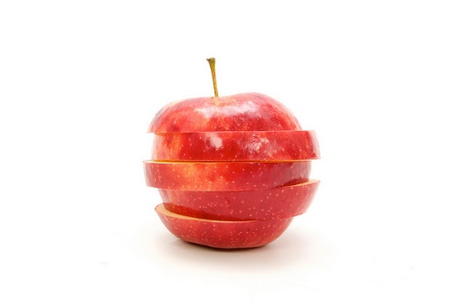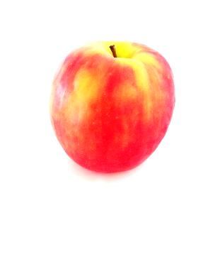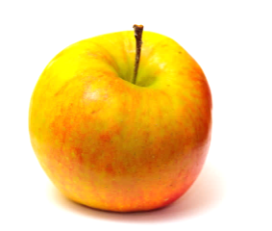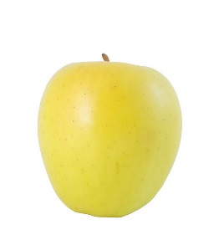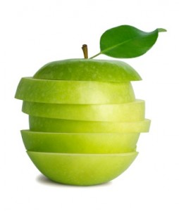

|  |  |  |  |
| --- | --- | --- | --- |
| **Sense** | **Tasting #1** | **Tasting #2** | **Tasting #3** |
| **Color** |  |  |  |
| **Texture** |  |  |  |
| **Smell** |  |  |  |
| **Sound** |  |  |  |
| **Taste** |  |  |  |

My favorite apple is: _____________.