Narrative Report - Outline

This outline can be used to draft your responses to the sections of the “Narrative Report” form before inputting them in the online Formstack form. Do not submit or upload this outline. Only submissions through the online Formstack form will be reviewed. Follow submission directions on the Final Report page on the Partner Portal.

Contact Information

Please complete the following information for the person completing this report.

- First Name
- Last Name
- Email
- Organization (Drop-down menu)

Program Overview

- Describe what success looks like for your program and summarize key successes achieved and/or meaningful steps taken toward success. Share successes or key steps that helped you advance your reach goals, program objectives, and PSE strategies/changes. (2,000 character limit, including spaces)

- What factors accelerated your progress this year? (2,000 character limit, including spaces)

- What factors inhibited your progress this year? (2,000 character limit, including spaces)

- Equity is at the core of SNAP-Ed’s purpose. Think about the community members who are marginalized because of their race, gender, language, education, ability, neurodiversity, mental health, housing, etc. Describe a) your efforts to reach diverse focus audiences and b) the factors that supported and the factors that limited their access to programming. (2,000 character limit, including spaces)

- How did you engage community members in program design, delivery, and improvement to meet their needs? (2,000 character limit, including spaces)

- Provide an example of how you adjusted programming to meet the unique cultural and/or contextual needs of the community(ies) you served over the program year. For DE, this could include adding new indirect channels to existing DE interventions, adjusting delivery methods for existing DE interventions, or adding new DE interventions to your program. For PSE, this could include adjusting how you worked with sites on PSE needs assessments and adopting changes or adding new PSE efforts to your program.

Questions 7 and 8 provide space to share what you are most proud of with partnership and collaborative work part of your SNAP-Ed program. Your responses may be featured in Michigan’s final report to USDA, so please write for audiences that are unfamiliar with your SNAP-Ed program and the communities you serve.

- Describe a PSE partnership (Evaluation Indicator ST7) you’re particularly proud of in your PSE work. What did this partnership achieve? What was SNAP-Ed’s unique role in this accomplishment? What learnings would you share with other SNAP-Ed agencies pursing similar PSE work? (2,000 character limit, including spaces)

- If this was your first year of programming, skip this item. For programs with at least two years of implementation, describe a multi-sector collaborative or coalition (Evaluation Indicator ST8) you’re particularly proud of in your PSE work. What did the collaborative/coalition achieve? What was SNAP-Ed’s unique role in this accomplishment? What learnings would you share with other SNAP-Ed agencies pursuing similar PSE work? (2,000 character limit, including spaces)

- Describe how you anticipate applying what you learned this year to your organization’s future SNAP-Ed work. (2,000 character limit, including spaces)

- If applicable, describe how you shared SNAP-Ed program learnings in presentations, journal articles, and other reports (include citations). (2,000 character limit, including spaces)

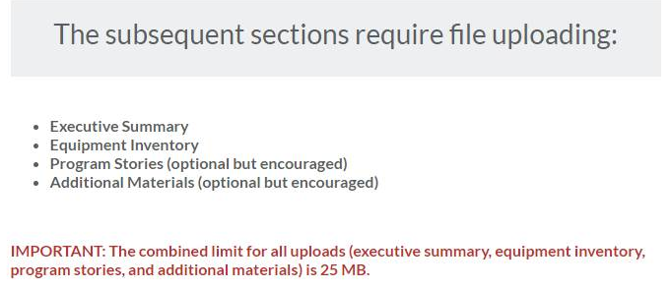

Executive Summary
Upload a one-page (not more than 500 words) Executive Summary of SNAP-Ed activities during FY 2022 This is reviewed by MFF, MDHHS, and USDA. Please write your responses for audiences that are unfamiliar with your SNAP-Ed program and communities you serve.

- Thinking about your SNAP-Ed program as a whole, describe how program components implemented across audiences and settings fit together to address community needs, achieve program goals, and complement other local/regional initiatives. Be sure to include DE interventions and PSE strategies used as well as settings and populations served.
- Program Approaches (Describe, in brief, approaches used to center the people you serve through SNAP-Ed in the design and delivery of programming.)
- Major Achievements

Equipment Inventory
Upload your Equipment Inventory.

Program Stories
Upload additional program stories capturing activities you’re proud of. Optional, but encouraged!

Tell us your story!

This is your opportunity to highlight work you’re proud of, which could include narrative, photos, quotes, short anecdotes, etc. Include all in a single document. If you include photos, you may want to resize them in order to decrease the file size to stay within the combined limit of all uploaded materials of 25 MB.

Additional Materials
Upload up to two new or innovative program materials or resources developed in FY 2022 here. Optional, but encouraged!

